CHAPTER 9: Energy transmission
Worksheet 9.3

Curved mirrors
Answers

Reflection from convex and concave mirrors
1. Four parallel light rays are incident on a convex and a concave mirror as shown. Complete the diagrams (using a pencil and ruler) to show the reflected rays.

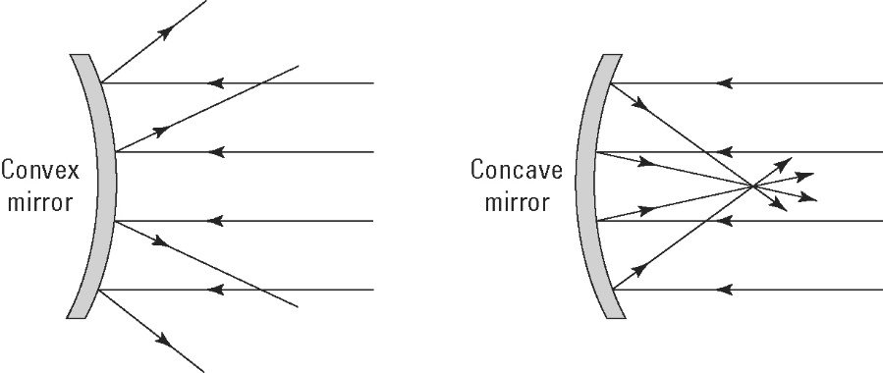

Light emitted from the focal point
2. The following diagram shows four light beams emitted from a light globe (L) placed at the focal point of the concave mirror.
(a) Use a pencil and ruler to show the direction of the light rays reflected from the mirror.

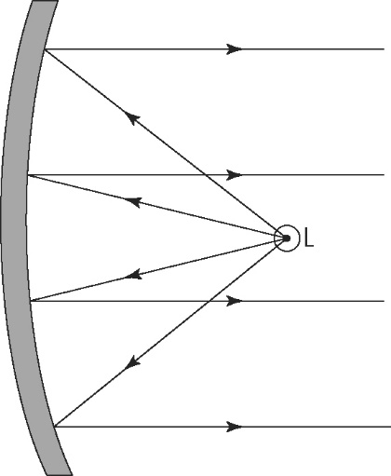
(b) Describe these reflected rays.
The reflected rays are straight and parallel.

